Name:Shivam

Write C++/Java program to draw circle using Bresenham‘s algorithm. Inherit pixel class.

#include<iostream>

#include<math.h>

#include<graphics.h>

using namespace std;

class cr

{

public:

float x1,x,y1,y,r,d;

void getc();

void bres(int,int,int);

void display(int,int,int,int);

};

void cr::getc()

{

cout<<"Enter the value of x : ";

cin>>x;

cout<<"Enter the value of y : ";

cin>>y;

cout<<"Enter the value of r : ";

cin>>r;

bres(x,y,r);

}

void cr::bres(int x,int y,int r)

{

d=3-2\*r;

x1=0,y1=r;

do

{

if(d<0)

{

d=d+(4\*x1)+6;

}

else

{

d=d+4\*(x1-y1)+10;

y1=y1-1;

}

x1=x1+1;

display(x1,y1,x,y);

}while(x1<y1);

}

void cr::display(int x1,int y1,int x,int y)

{

putpixel(x1+x,y1+y,RED);

putpixel(x1+x,y-y1,RED);

putpixel(x-x1,y1+y,RED);

putpixel(x+y1,y-x1,RED);

putpixel(x-x1,y-y1,RED);

putpixel(x+y1,y+x1,RED);

putpixel(x-y1,y+x1,RED);

putpixel(x-y1,y-x1,RED);

}

int main()

{

int x;

cr c;

int gd=DETECT,gm;

initgraph(&gd,&gm,NULL);

outtextxy(200,100,"Bresenham's circle algorithm : ");

c.getc();

getch();

closegraph();

return 0;

}

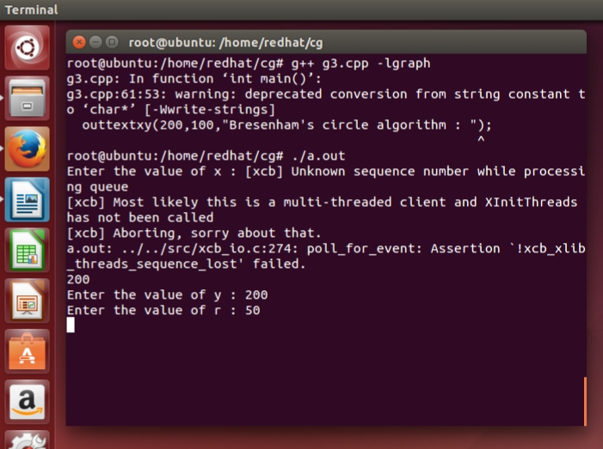Output: -

